

**Scheme for Measuring Number and Height of Human**

**with TFmini-Plus**

# Instructions

This program is a small device developed by using the combination of TFmini-Plus and Arduino-UNO boards of the Benewake (Beijing) Co. Ltd.

Role: Statistic the number of people and height of corresponding target.

1. **Test Equipment and Wiring**

## Test Equipment

* **Benewake TFmini-Plus Standard Edition**

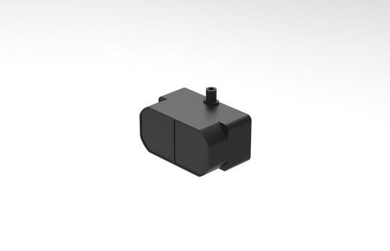

For detailed parameters, please refer to the TFmini-Plus product manual.

* **Arduino-UNO Board**

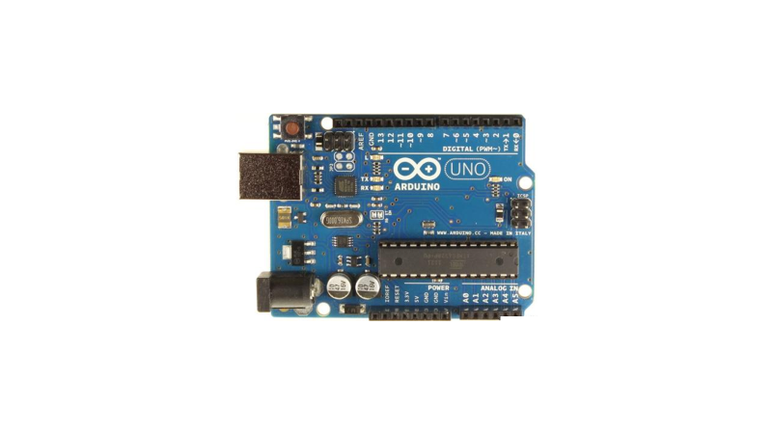

For a detailed introduction and study of Arduino UNO board, please refer to the following two websites:

Chinese Community：http://www.arduino.cn/；

English Official Website：http://www.arduino.cc/.

* **Computer**

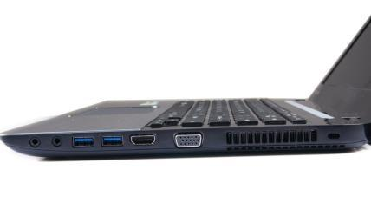

The function of a computer is to write and upload programs and display data.

The function of data display can be upgraded and optimized later, such as adding a screen to display current number and height data of people, and using speakers to voice greetings such as "welcome".

* **Cable**

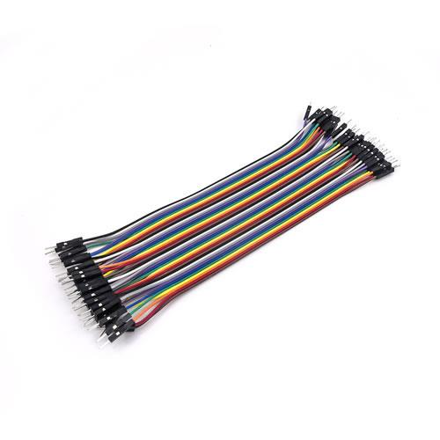 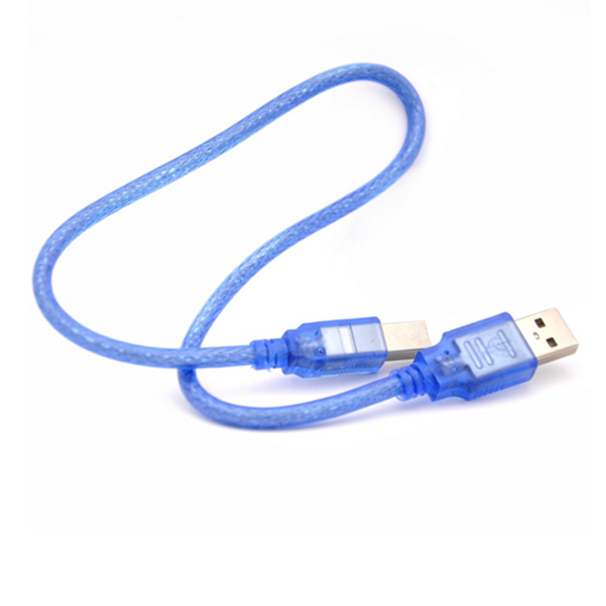

DuPont line -used for Plus and UNO board connection(plus terminal is detachable);

USB square port data cable - used for UNO board and computer connection

* 1. **Wiring**

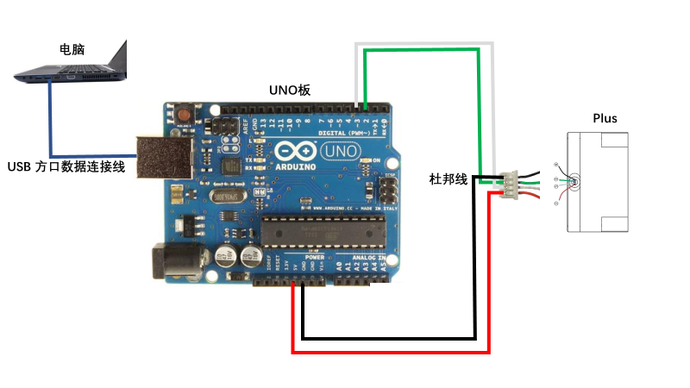

The line order of TFmini Plus product is defined as: red is +5V, black is GND, green is TX, white is RX; So you can directly connect to 5V and GND of Arduino board. Please consult the product datasheet for other radars to ensure the normal power supply.

the serial communication connection needs to pay attention to: For Arduino UNO board, the TX end of radar is connected with pin 2 port of board (RX of soft serial port Serial1), The RX terminal of the radar is connected with pin 3 port of the board (TX of soft serial port Serial1), which is related to the program writing in the following part.

# Principle of Measurement

* After the radar is started, set the installation height, the upper limit and lower limit of the height of the person.
* When a person enters the detection area, the data will rise and the number of people will be output. For each occurrence, the number of people will increase by one and the number of people will be output.
* When the person is in the detection area, the data will fluctuate above the height limit. At this time, the value of Height is set, and the height is the maximum value of the data fluctuation of the person in the detection area.
* When a person walks out of the detection area, the data will drop and output “Height”.

# Program Flowchart

# Programming

The implementation of this routine requires at least two serial ports, one for receiving radar data and the other for displaying the data output to the computer. You can copy the following code and paste it into the IDE program editing window, or you can open the corresponding attachment file directly.

attachment：

#include<SoftwareSerial.h>//header file of soft serial port

SoftwareSerial Serial1(2,3); //define the soft serial port name as Serial1, and set pin2 as RX and pin3 as TX.

/* For an arduino board with multiple serial ports, such as the DUE board, comment out the above two pieces of code and use the Serial1 serial port directly. */

int dist;//Range measured by Radar

int strength;// The strength of the radar signal, the strength below 100 is not credible

int IH=230;//radar installation height (to be set), it needs to be corrected for the actual black object

int H;// Height

int h=0;// Last height

int check;// Check value storage

int i;

int Number=0;//

int Height=0;//Maximum height

int up=50;//Height limit (need to be set), the height of the object is valid above this value

int down=40;//Lower limit (to be set) to prevent data fluctuation and wrong data when the height is at the exact height limit

int uart[9];// Store radar measured data

const int HEADER=0x59;//

void setup()

{

Serial.begin(115200);// Set the baud rate of the arduino and computer connected serial port

Serial1.begin(115200);// Set the baud rate of the serial port connected to the radar and arduino

}

void loop()

{

if (Serial1.available())//Check if the serial port has data input

{

if(Serial1.read()==HEADER)

{

uart[0]=HEADER;

if(Serial1.read()==HEADER)

{

uart[1]=HEADER;

for(i=2;i<9;i++)// Storing data into an array

{

uart[i]=Serial1.read();

}

check=uart[0]+uart[1]+uart[2]+uart[3]+uart[4]+uart[5]+uart[6]+uart[7];

if(uart[8]==(check&0xff))// Verify the received data according to the protocol

{

dist=uart[2]+uart[3]*256;// Calculate the distance

strength=uart[4]+uart[5]*256;// Calculated signal strength

H=IH-dist;// Calculating height

/* The number of measurements */

/* Principle: increase the number of people by 1 when the data exceeds the height limit from the lower limit*/

if(H>=up&h<down)// When people enter the measurement area, add one to the number

{

Number=Number+1;

h=H;

Height=H;

Serial.print("Number = ");

Serial.print(Number);//

Serial.print('\t');

}

if(H>=up&h>=down)// When the person is in the measurement area, the maximum value of the period is obtained by comparison

{

if(Height<H)

{

Height=H;

}

}

if(H<down&h>=up)// When the person walks out of the measurement area, the maximum height is output and the maximum value is reset to zero.

{

Serial.print("Height = ");

Serial.print(Height);//

Serial.print('\n');

h=H;

Height=0;

}

// Serial.print("H = ");

// Serial.print(H);//

// Serial.print('\t');

// Serial.print("dist = ");

// Serial.print(dist);//

// Serial.print('\t');

// Serial.print("strength = ");

// Serial.print(strength);//

// Serial.print('\n');

}

}

}

}

}

1. **Data Viewing**

Upload the program to the Arduino board and open the serial port monitor to see the number of people detected by the radar in real time and the height of the corresponding target.

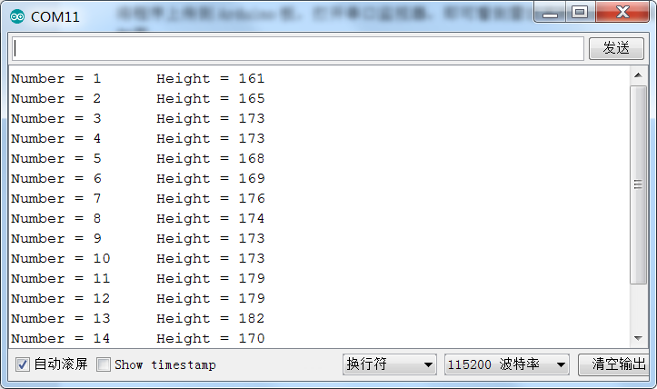

1. **Cautions**

* The installation height needs to be corrected according to the actual black object, because the radar receives different signals with different reflectivity of objects of different colors.
* When multiple people walk together, the radar spot can only hit an object, can only count plus 1, suitable for single access to the scene.
* If the spot does not reach the top of the head completely, the height data will be wrong. Considering that the height of the person will float when walking, try to let the foot fall around the spot to detect the highest value and reduce the error.
* The buffer area is "height limited-lower limit", which avoids the data fluctuation of repeating the number of people plus 1 when the height is exactly in the "height limit" .